***Challenge 21***

**Goal:**

Add read more and give link to it like below figure.

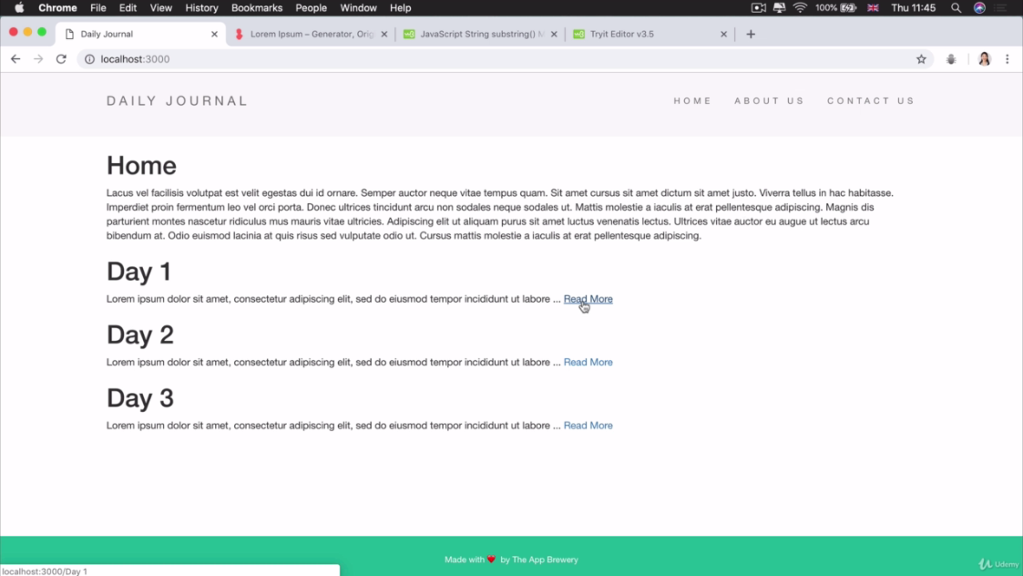

Solution:

Add anchor tag <a> and give it link

<a href="/posts/<%=post.title%>">Read More</a>

**Complete code of home.ejs:**

<%- include('partials/header'); -%>

<h1>Home</h1>

<p><%= startingContent %></p>

<% console.log(posts); %>

<% posts.forEach(function(post){ %>

<!-- <% console.log(posts.title); %> -->

<h1><%= post.title %></h1>

<p><%= post.content.substring(0,100) +"..." %>

<a href="/posts/<%=post.title%>">Read More</a>

</p>

<% }); %>

<%- include("partials/footer"); -%>